Daniel Moloney C15446648

# Question 1:

1 GET /users

Code

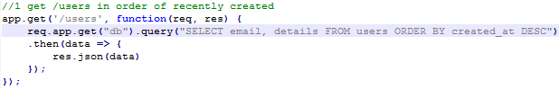

Output

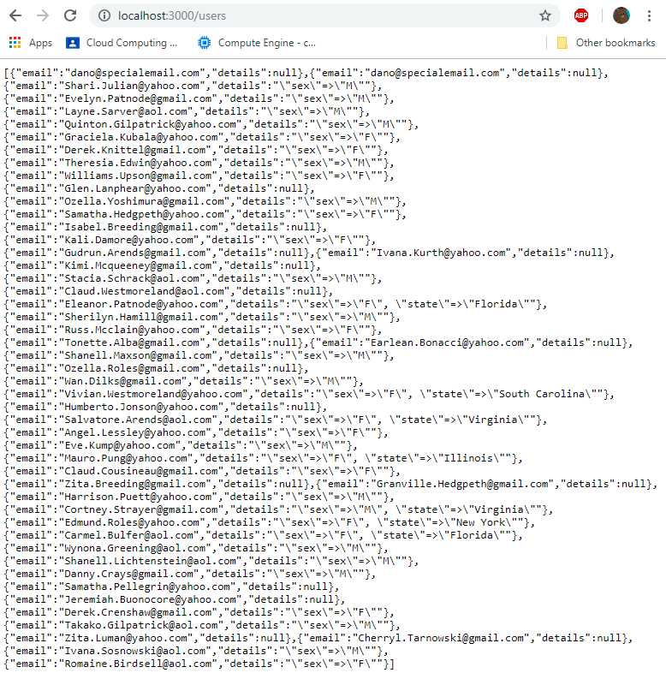

1 GET /users/:id

Code

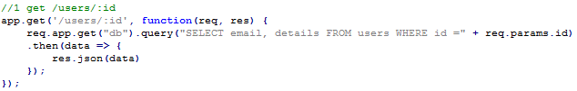

Output

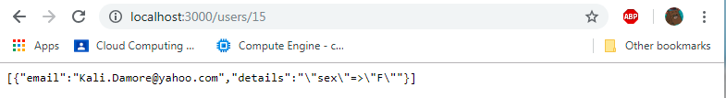

1 GET /products

Code

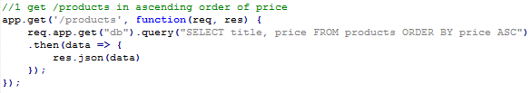

Output

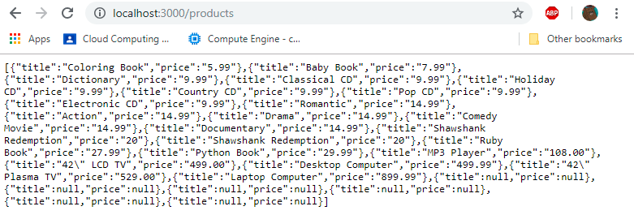

1 GET /products/:id

Code

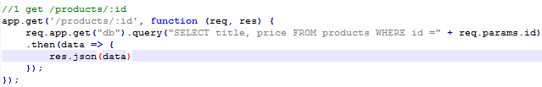

Output

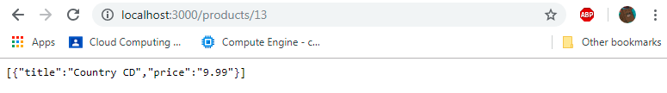

1 GET /purchases (uses joins etc)

Code

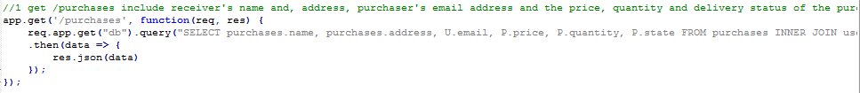



Output

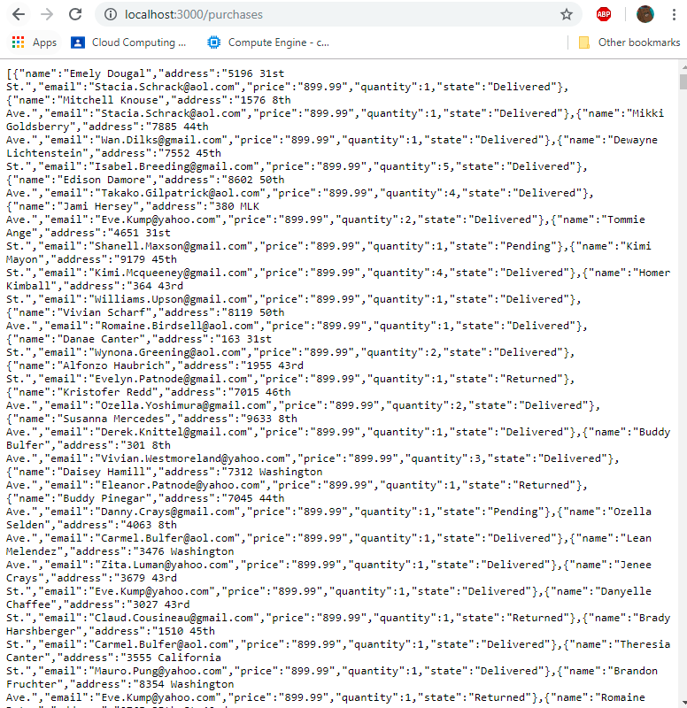

As you can see above, the output scrolls on and on (full query is loaded)

2 GET /products/?name sql injectable

Code

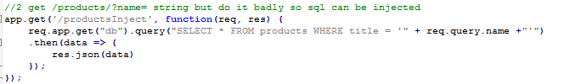

Before injection

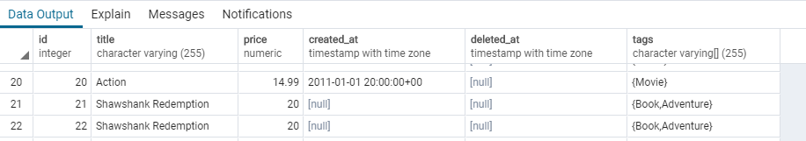

Injection

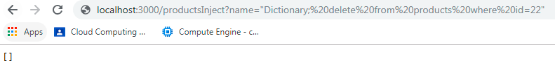

Result of injection

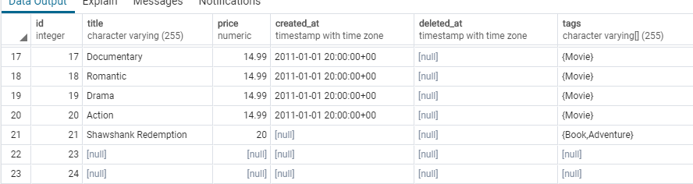

3 Solution to injections

a)

parameterisation

Code

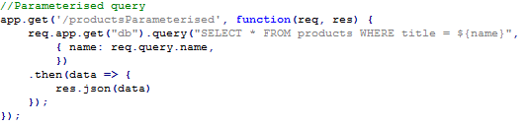

Injection

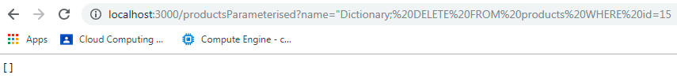

Result (no loss of product with id 15)

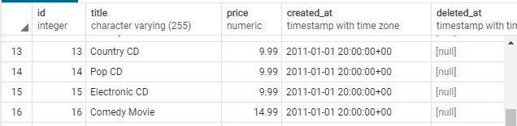

b)

stored procedure

Code

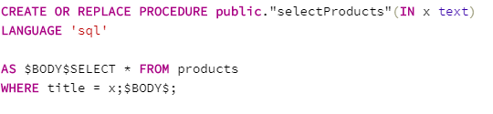

Similarly to parameterized approach, output showed injection failed (same id used)

